**PNRR: Funds for modern and reformed Romania!**

**The title of the project**: The creation and development of the Center for orientation, association, and counseling in the research career for the North-East Development Region of Romania within the "Ştefan cel Mare" University in Suceava - COACH USV financed by

National Recovery and Resilience Plan Call no. PNRR-III-C9-2022 – I10

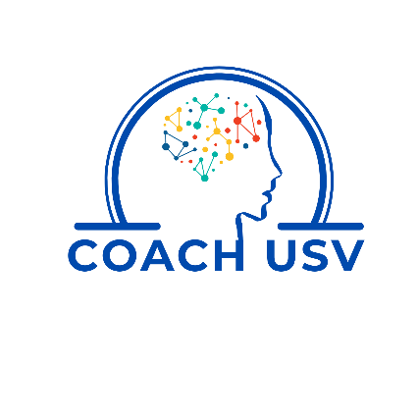

**AGREEMENT CONCERNING THE PROCESSING OF PERSONAL DATA**

The undersigned, _________________________________________________, domiciled in _____________________, county ___________________, street _______________________, no. ____, born on _____________________, identified by ______, series _____, no. ____ PIN (pers. id. no. ) ___________________, e-mail _______________________, telephone ___________________ as a student/ doctoral student/ postdoctoral researcher/ researcher, I express my consent for the use of my personal data provided by this application to be processed by "Ștefan cel Mare" University of Suceava, as a data operator personal data, for educational and cultural purposes, in accordance with EU Regulation 679/2016 on the protection of natural persons with regard to the processing of personal data and on the free movement of such data.

I acknowledge that I benefit from all the rights provided by EU Regulation 679/2016 and published a t[www.usv.ro](http://www.usv.ro/)- Protection of personal data.

Date _______________Signature _______________________